The Biblical Drama
by T. Pandit

Foreword
This Bible study is presented in the form of a dialogue between a Bible teacher, Pandit, and his student. It is good if the text is read aloud. The participants in the Bible study group can take turns reading, one reading the words of Student, another reading the words of Pandit. After a while two other persons can read – and so on.
After each unit there are questions. These can be used for group discussions.
Each group should have 4–7 members. Do not have larger groups. Try to involve all the group members in the discussions.
The Bible quotations are based on the World English Bible (WEB) translation.
T. Pandit has many years of experience as an educationist, as a Bible teacher and as a college principal, in India as well as internationally.
S. Sarbasst is a graphic designer and an artist based in Europe. He has drawn most of the maps.
The author of this work hereby waives all claim of copyright (economic and moral) in this work and immediately places it in the public domain. It may be used, distorted or destroyed in any manner whatsoever without further attribution or notice to the creator.
New edition February 2019

Introduction
Student
Good evening, Sir. Today I want to ask you to explain to me about the Bible. It is a very big book. And within that book there are many other smaller books. And these smaller books are so different from each other. I find this quite confusing.
Pandit
In one way the Bible is one book, as all the smaller books are bound into one big volume to show that they all belong together. When you open the Bible you find that it consists of two main sections. Which are they?
Student
That is an easy question, Sir. The first part of the Bible is the Old Testament. The second part is the New Testament. The Old Testament is much bigger than the New Testament. I also know how many books there are in the Bible. The Old Testament has 39 books and the New Testament has 27 books. So altogether there are 66 books in the Bible. This I learnt at a Youth Bible Camp last year.
Pandit
Very good! These 66 books were written by more than 40 different authors during a period of perhaps 1500 years. These authors were not only separated from each other in time and space. They also had different social backgrounds. Some were kings or political and religious leaders. Others were philosophers, poets or fishermen. One was perhaps a farmer, another one was a doctor, yet another one was a tax collector.
Student
Yes, I know that David, who wrote many of the psalms, was a king. And Luke, who wrote Luke’s gospel and the book of Acts, was a doctor. And Matthew, one of Jesus’ disciples, who also wrote a gospel, was a tax collector. And Jesus’ disciple John, who wrote a gospel, some letters and the book of Revelation, was a fisherman before he left his nets and followed Jesus.
Pandit
The books of the Bible were also written at many different places and in different cultures, during the times of different world empires. They were written in many different circumstances – in deserts, in prison cells, in palaces, during journeys, during wars, in times of great difficulties and sufferings, in times of peace, in times of success and prosperity. Some texts were written in times of despair and sadness. Other texts were written in times of joy and happiness.
Student
I have read the Psalms a lot and there I find all kinds of situations and emotions. But the Psalms are very different from most of the other books in the Bible.
Pandit
You are right. The Bible contains many different kinds of texts. In the Psalms there is poetry. But there are also many books that contain historical texts. In other books we find prophecies, laws, proverbs, dramas and letters. And the last book of the Bible is a revelation. These different texts deal with many topics that are important for our lives.
But it is really wonderful that in spite of all these variations and differences we can find an incredible harmony and unity and continuity from the first book of the Bible to the last book. There is one theme that ties all these books and texts together. And that theme is the message about a living and personal God, who has revealed his grace and love for the salvation of mankind through Jesus Christ, the Son of God. This great theme is undoubtedly the reason why the Bible has been loved and read more than any other book in the world.
Student
But some people say that the Bible is a Western book. They say that it is written by Western people for Western people and that it is not relevant for us who live in India.
Pandit
This is totally wrong! The Bible is not a Western book. Almost all the authors of the books in the Bible were from Asia. And most of the stories recorded in the Bible take place in the parts of Asia that we nowadays call the Middle East. The languages that the Old Testament was written in – Hebrew and Aramaic – are Asian languages. But the New Testament was written in Greek, which is an Indo-European language just like Sanskrit or Hindi or Bengali.
No, the Bible is a book for all people and for all times! No other book in human history has spread to every nook and corner of the world. The Bible has been translated into thousands of languages. It has been printed in crores and crores of copies. It has been read and appreciated in almost every country in the world. No other book in the world has had so much influence on people. The Bible has influenced people in Europe, Africa, Asia, North America, South America, Australia and the Pacific Islands. Everywhere! The Bible has influenced people throughout history. Most great leaders in the world have been influenced by the message of the Bible. Mahatma Gandhi our greatest freedom fighter read the Bible regularly. No, as I said before: the Bible is a book for all people and for all times. It definitely has a message for the people of India in our time and age.
Student
Yes, it has definitely has had a message for me!
Questions
- How many books are there in the Old Testament, in the New Testament and in the whole Bible?
- What kind of people wrote the Bible?
- What different kinds of texts are there in the Bible?
- What is the most important theme in the Bible?
- Why is the Bible not a Western book? Discuss!

The stage of the drama
Pandit
To help you get a better grasp of the Bible I will present it to you as a drama. Have you ever seen a drama performed in you village?
Student
Of course I have! Ever since I was a child I have seen groups of performers come to my village to enact stories from the Ramayana and other Indian classics.
Pandit
So what do we find in a drama?
Student
There are actors, who perform a long story, which usually has several parts or acts and scenes. Is that what you mean?
Pandit
Yes. We can say that a drama performance consists of three different things. First, you have the stage or the place where the story takes place. Often, as the story moves from one scene to another, you have many stages or places. Second, you have the actors, who perform the different parts of the drama. Third, you have the story, which is usually made up of several acts and scenes.
Student
I agree with you Sir. So what is the stage of the Bible story?
Pandit
The stage or the geographical area in which the Bible story takes place starts around the two big rivers Tigris and Euphrates in the east – but this “east” is of course west of India. It is where modern day Iraq is situated. Then in the center-stage we find the area where the modern countries of Israel, Palestine, Syria, Jordan and Egypt are situated today. Finally to the west we come to the modern countries of Turkey (which was called Asia during the times of the apostle Paul), Greece and Italy.
Student
So, where does the drama start? In the east, the center or the west?
Pandit
The story in the first book of the Bible, Genesis, starts in the area of the two rivers Tigris and Euphrates. In Genesis 2:8–14 we read that God planted a garden in Eden in the east (which must mean east of Israel) and that four rivers watered the garden. Two of these rivers were Tigris and Euphrates. The first human beings Adam and Eve had two sons. Cain was a farmer and Abel was a shepherd. This shows how people made a living early in the history of mankind. But very soon the Bible tells us that Cain built a city. From archeological evidence we know that the early culture in this area was based on cities. Also the great flood can be linked to this area. We know that the ark through which Noah and his family were saved came to rest on the mountain of Ararat. The sources of the rivers Tigris and Euphrates can be found in this mountain range.
In the southern part of this geographical area, called Babylon in the Bible, the city of Ur was situated. This, very important city was the hometown of Abraham. In about BC 2000 Abraham left Ur and moved north to Haran, where he stayed until his father had died. Then he moved east and south to the country of Canaan, which became his new home. He lived there in different places, but during a period of famine he traveled further south to the country Egypt and the Nile River, where he spent some time. So Abraham moved over the whole geographical area, where the rest of the Old Testament story takes place. Egypt at one end and Babylon at the other end are the two countries in which the children of Israel later spent two long periods of captivity. And Canaan lies in between these two ends. If we look at a map this whole geographical area looks like a semi-circle or like the crescent of the moon. And it is often called the “Fertile Crescent” even today.

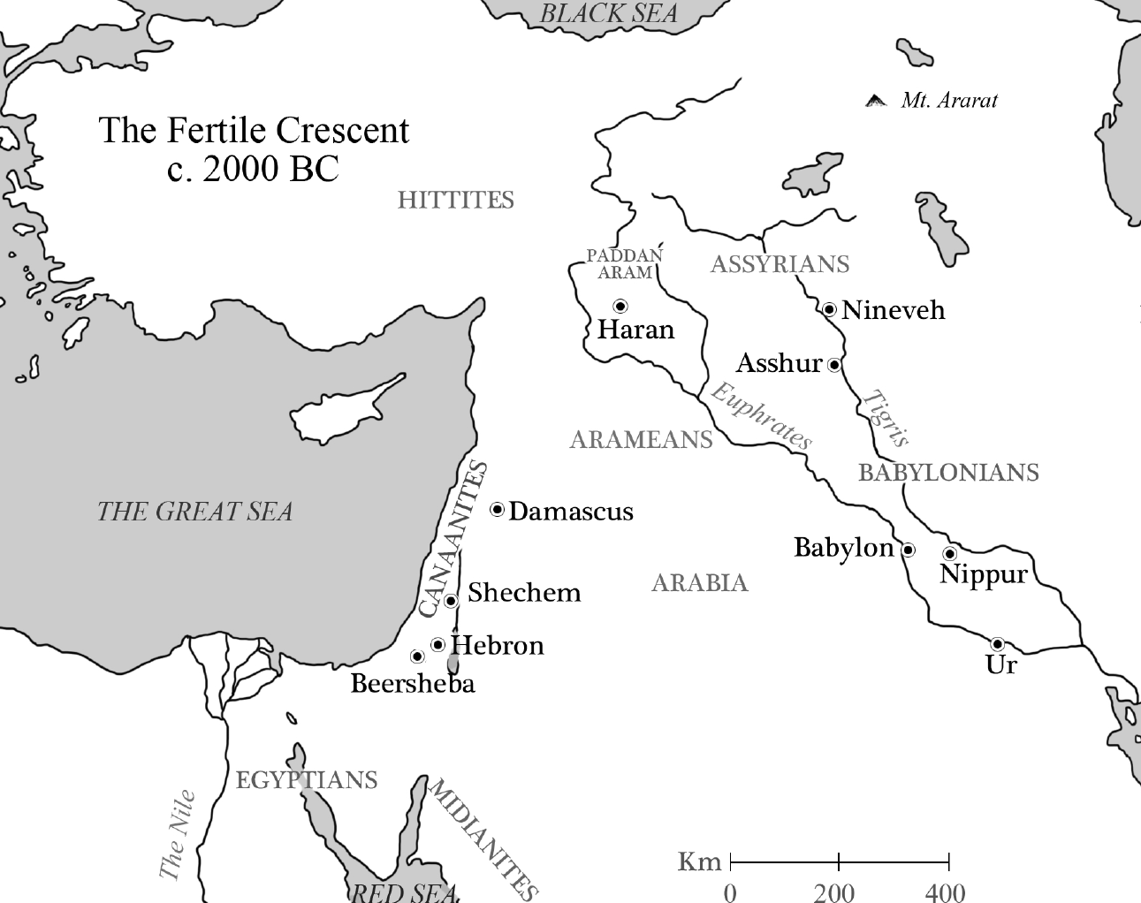
Map: The Fertile Crescent
Student
It is quite interesting that Abraham moved over the whole stage of the Old Testament. This must mean that the rest of the Old Testament story comes back again and again to these same places and countries?
Pandit
Yes, that is true. Now let us look a little more closely at the center-stage, which is the land of Canaan. God describes it to Moses as a good and large land, a land flowing with milk and honey (Exodus 3:8). It is not a very big country, only 350 km from north to south (the distance from Bangalore to Hubli) and 150 km from east to west (the distance from Chitradurga to Hassan). So it is much smaller than Karnataka. But within this small country there was big geographical variation.
To the west – along the Mediterranean Sea – there was the coastal plain with the land of the Philistines. In the north, this plain cut east into the hilly regions to form the Valley of Jezreel. East of the coastal plain were the foothills with their soft hills and winding valleys. This part of the country was famous for its sycamore-fig trees. East of the foothills came the higher mountains where Jerusalem was situated. A traveler going even further east would enter the Desert of Judah, which during the winter months had sufficient grass for herds of sheep to graze. This was the desert where king David hid when Saul was trying to kill him and where Jesus spent 40 days fasting and was tempted by the devil. Then the traveler would have to descend deep down into the Jordan valley. This is the deepest part of the world. The river Jordan runs from Mount Hermon in the north, through the Sea of Galilee and down to the Dead Sea, which is situated 400 meter below the sea level! During the Old Testament times this valley was covered by thick forests with wild animals.
Finally, east of the Jordan the traveler would reach a vast mountain plateau, where the tribes of Gad, Ruben and half of Manasseh were given their tribal territories after the 40 years in the wilderness. This plateau is divided into sections by three rivers running down into the Jordan River and the Dead Sea. One of them Jabbok, where Jacob fought with God, is situated halfway between the Sea of Galilee and the Dead Sea. Further south, Arnon runs into the Dead Sea. In this area we find three of the most frequently mentioned peoples in Old Testament times. The country of the Ammonites lay between the rivers Jabbok and Arnon, and the Moabites lived south of the river Arnon. It was from a mountain in Moab that Moses could look into the Promised Land before he died. The Edomites ruled the country south of Moab, south of the Dead Sea.

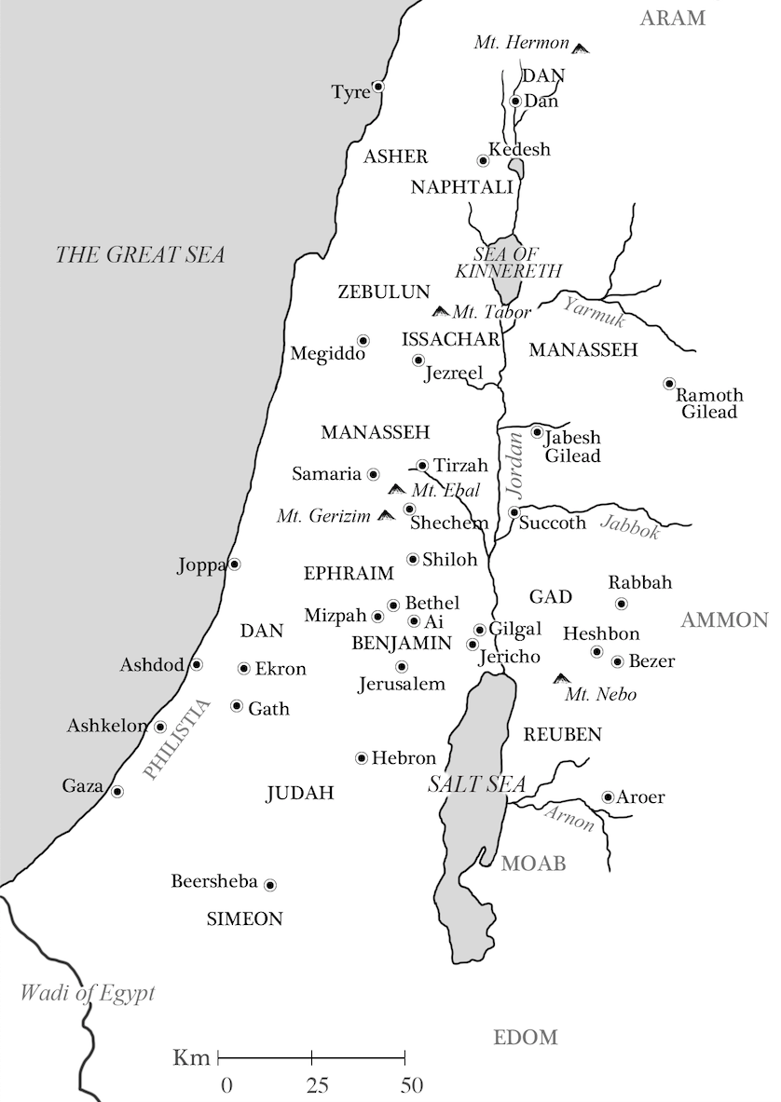
Map: Land of Canaan
Student
Thank you for this interesting description, Sir. But in what way was this geographical area of Canaan different in Jesus’ time compared with Old Testament times?
Pandit
Well, in many ways it was quite similar. The main difference was the political situation. In New Testament times we find three distinct areas of the country (which at that time often was referred to as Palestine): Galilee, Samaria and Judea. Galilee was in the north. The name means “district," that is “the Gentile district," because after all wars during the Old Testament times many different peoples had moved into this area. It was dominated by the Sea of Galilee, which is a rather small lake (30 km by 13 km) surrounded by mountains. There were important cities on this lake. One of them, Capernaum, is mentioned many times in the gospels.
South of Galilee we find district of Samaria. This district got its name from the capital, also called Samaria, of the kingdom of Israel, the northern of the two Israelite kingdoms during the Old Testament times. This kingdom was conquered by the Assyrians in BC 722. They forced people of other nationalities to move into the area. This resulted in a people of mixed ethnic background called Samaritans, who believed in the first five books of the Old Testament and who built their own temple (which was destroyed before the New Testament time). During the time of Jesus there was much tension between Jews and Samaritans, and Jews avoided to travel through Samaria on their way from Galilee to Judea.
Finally Judea was the name of the southern-most part of the country. This was the area of Judah, the name of the southern of the two Israelite kingdoms in Old Testament times. But the Romans, who were the rulers during the days of Jesus, used the name Judea for the whole country – including Samaria and Galilee. It was also called Palestine.

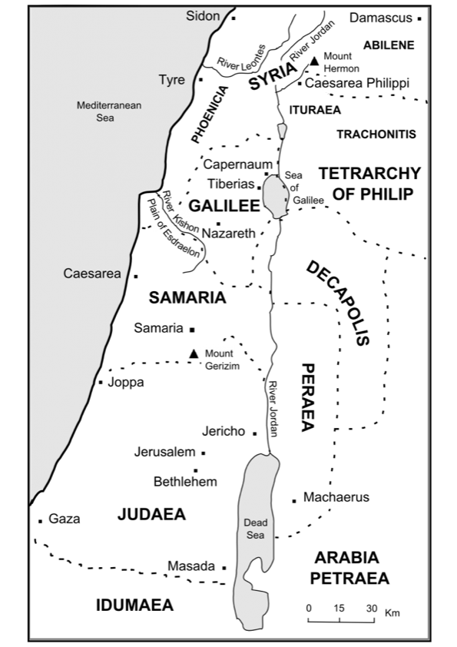
Map: Palestine at the time of Jesus
Student
So, now you have described the whole “stage” for the drama of the Biblical story?
Pandit
No, not quite. I must add one more geographical area. In the book of Acts we find the stage for the final scenes in the New Testament story. After the first Day of Pentecost the gospel of Jesus Christ was spread to many countries and cities and peoples around the Mediterranean Sea. The story about the apostle Paul in the book of Acts ends in Rome, the capital of the Roman Empire and the most important city at that time. [Map in the following page]
Student
Thank you, Sir. I will try to remember all these countries and places, which make up the stage for the Biblical drama!
Questions
- The Pandit compares the story of the Bible with a drama. What are the three most important components of a drama?
- What is the “stage”?
- Describe the geographical area where the Bible story starts.
- Which countries did Abraham visit? Give some information about them!
- What is “the Fertile Crescent”?
- Describe the land of Canaan from the west to the east?
- Where did the Philistines live?
- Where was Jerusalem situated?
- Mention one interesting geographical fact about the Dead Sea!
- Who were the three important nations east of the Jordan River during Old Testament times?
- Describe Palestine (or the Roman territory of Judea) during New Testament times from north to south.
- What is the “stage” of the ministry of the apostle Paul in the book of Acts?

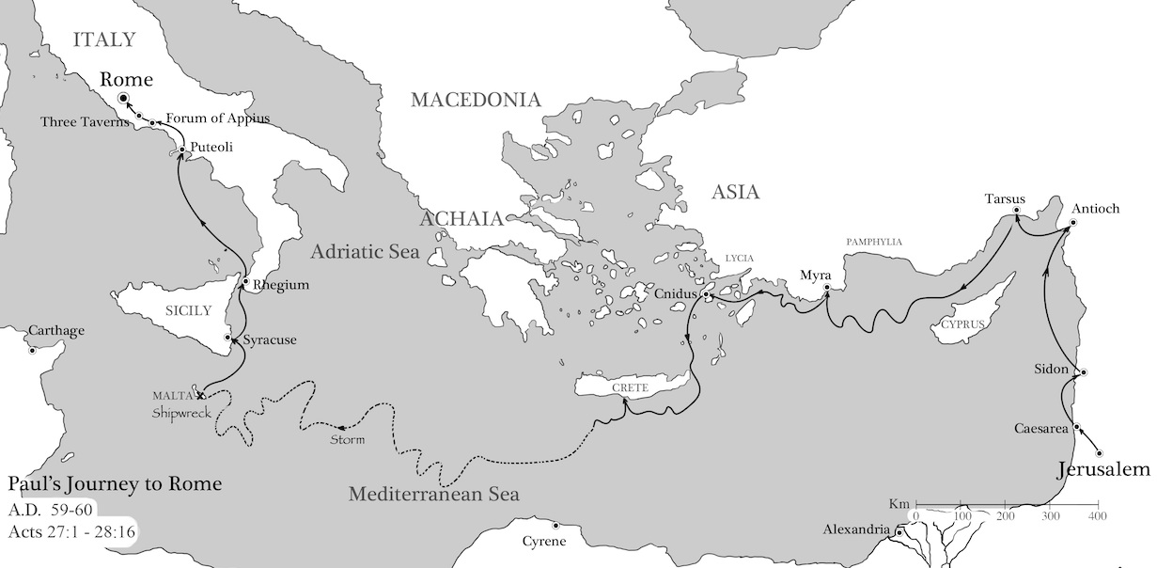
Map: Paul’s journey to Rome

The actors of the drama
Student
So, now you have described to me the stage or the geographical area, in which the Biblical drama takes place. Next you must introduce the “actors”!
Pandit
So who do you think is the most important “actor” in the Bible?
Student
I am not sure. But probably the people of Israel. No, if we include both the Old and the New Testaments I should perhaps say “God’s people” instead.
Pandit
The people of Israel or “God’s people” are of course important. But that is not the correct answer. There is one even more important “actor” in the Bible. Just think a little! Who started the whole drama? Who is the first one mentioned in the Bible?
Student
How stupid I am! Of course it is God!
Pandit
Yes, of course. The first verse in the Bible says, In the beginning God created the heavens and the earth (Genesis 1:1). He is also the one who in the middle of the drama steps into the scene, when he becomes flesh in Jesus Christ. In John’s gospel we read, In the beginning was the Word, and the Word was with God, and the Word was God. … The Word became flesh and lived among us. We saw his glory, the glory as of a father’s only son, full of grace and truth. … No one has ever seen God, but God the only Son, who is close to the Father, has made him known (John 1:1, 14 and 18). He is also the one who will finally sum up the whole drama so that God may be all in all (First Corinthians 15:28).
But then God summons individuals as well as peoples onto the stage. This happens in the storyline of the drama both in the Old Testament and in the New Testament. Regardless of the actors that come onto the stage, the purpose is always that God’s glory, righteousness and love should become evident to these actors as well as to those who watch or read the drama.
The first part of the biblical drama (that is the Old Testament) focuses on the people of Israel. So you were partly right when you put the people of Israel in the center of the drama! This nation has three patriarchs (or original ancestors) – Abraham, Isaac and Jacob. In Genesis chapter 12 Abraham is called by God to leave his hometown Ur in order to become the beginning of a new nation – the people of Israel.
But in the background throughout this first part of the story we have all of mankind. The things that happen to the people of Israel always have a link to all the peoples of the earth. When God calls Abraham he tells him, “I will bless those who bless you, and the one who curses you I will curse. In you all the nations of the earth will be blessed.” (Genesis 12:3)
In the second part of the drama (that it the New Testament) another group of people is formed and they are placed in the center of the stage surrounding the main character in this part of the drama – that is Jesus. In the beginning this group only consists of a small number of Jewish men – the disciples. But soon all kinds of people from many different nations of the earth are included. This group it the church!
But around these two main groups of actors – the people of Israel in the Old Testament and the Christian church in the New Testament – there are many other groups of people from different nations who play important roles in the Biblical drama during different periods throughout history.
Student
So who are these people?
Pandit
There are many peoples and nations that are part of the biblical drama. I will only tell you a little about the most important of them. And I will mention them in the approximate historical order in which they relate to the biblical drama.
The Hittites were one of the peoples who lived in Canaan before Abraham came there (Genesis 15:18-21). Later the Hittites become one of the great nations in the world and covered most of present-day Turkey. They made covenants with the people of the countries that they conquered. These covenants are very similar to the covenant God made with the people of Israel.
The Ammonites descended from Abraham’s nephew Lot. During the Old Testament times they lived in the area of the Jabbok river. They are described as very cruel. They gouged out the eyes of their enemies (First Samuel 11:2) and they ripped open pregnant women (Amos 1:13). The people of Israel were forbidden to have any contact with them, and there were many wars between these two nations. Because the Ammonites insulted and mocked the people of Israel, God wiped them out from the face of the earth (Zephaniah 2:8-10). This happened about 200 years after Christ.
The Moabites were closely related to the Ammonites, as they were also descendants of Lot. That means that they were also related to the Israelites. Their country was situated east of the River Jordan and south of the country of Ammon. It was in this territory that Moses gave his farewell speech to the people of Israel (Deuteronomy 1:5). During the time of king Saul many wars were fought between Moab and Israel. Later king David conquered Moab.
The Edomites lived south of Moab and south of the Dead Sea and they descended from Esau, the brother of Jacob the patriarch. Moses and the Israelites were not allowed to pass through Edom on their way from the captivity in Egypt to the Promised Land. Much later king David and king Solomon conquered Edom. During the time of the Divided Kingdom there were many wars between Judah and Edom. Later the Edomites had to move north into the southern parts of Judah where they were forced to convert to the Jewish religion. Herod the Great, who was king at the time of the birth of Jesus, belonged to this people.
Egypt has a history that goes all the way back to before 3000 BC. Many times the Egyptians enter the stage of the biblical drama. Abraham went down to Egypt and spent some time there. Joseph was sold into captivity in Egypt. But later he became one of the most powerful men in the country and he brought his whole family there to save them from famine. This probably happened around 1800 BC. A few hundred years later the people of Israel had become slaves under the Egyptians. But God sent Moses to deliver the people and to bring them back to the Promised Land. In a later period king Josiah of Judah died in a war against Egypt a little before 600 BC.
The Philistines invaded the eastern shores of the Mediterranean Sea around 1200 BC and settled on the coast in the southern part of Canaan. Their nation consisted of five fortified cities: Ashdod, Ekron, Gaza, Gat and Ashkelon. From the time of the Judges and to the time of king David there were constant wars between the Philistines and the people of Israel. A very well known story is the fight between the young David and the giant Philistine Goliath. David was victorious in the name of the Lord Almighty (1 Sam 17:45).
Assyria was situated in the northern part today’s Iraq. About 1500 BC Assyria and Egypt were among the most powerful nations in the world. In 722 BC the Assyrians conquered the northern kingdom of Israel and deported the people (Second Kings 18:9-11).
The history of Babylon goes all the way back to 2300 BC. It becomes a world power for the second time around 600 BC and that is when we meet the Babylonians in Old Testament story. King Nebuchadnezzar invaded the southern kingdom of Judah one final time in 586 BC and destroyed the Jerusalem temple that had been built by king Solomon. The people were taken into captivity in Babylon.
The Persians came to world power as king Cyrus conquered Babylon in 539 BC (Ezra 1:1) and then went on to conquer most of the countries of the Old Testament. The home area of the Persians was situated where we find Iran today. King Cyrus allowed the people of Israel to return from their Babylonian captivity to Palestine.
The Greeks had a very famous king around 340 BC. His name was Alexander and he was called the Great. He not only conquered all the countries from Greece to India. He also spread Greek culture and the Greek language. This had an enormous influence on Palestine and all surrounding countries. The Old Testament was translated into Greek, and all the books of the New Testament were written in Greek. The Greek culture and language dominated the whole New Testament world, although the political power was in the hands of the Romans.
The Roman Empire is the last world power mentioned in the story of the Bible. In 63 BC the Romans conquered Palestine and at the birth of Christ the Roman Empire surrounded all of the Mediterranean Sea and was spreading north into the central parts of Europe. Many of the Roman emperors were connected with the New Testament story. Jesus was born during the reign of Caesar Augustus (Luke 2:1). Jesus’ ministry and crucifixion took place during the reign of Tiberius (Luke 3:1). The missionary journeys of apostle Paul took place during the reigns of Claudius (Acts 18:2) and Nero. The Roman general Titus, who later became emperor, captured Jerusalem and destroyed the temple in AD 70. Most Bible scholars believe that the book of Revelation was written during the persecutions under emperor Domitian around AD 90.
Student
Sir, So many people to remember! Of course, some of them I have heard about before. But many are new to me. Do I really need to know all these peoples? Their names, their countries, their place in history, their connections with the people of God?
Pandit
So you find this information confusing? But I have only given you a few of the most important facts. There are many more peoples mentioned in the Bible. All this information may not seem important or relevant, but to know these things will make it easier for you to understand the stories of the Bible. God has used nations and spoken to nations all through history. And God speaks to us through them. As the apostle Paul writes, These things happened to them to serve as an example, and they were written for our instruction, on whom the ends of the ages have come. (First Corinthians 10:11)
Questions
- Who is the most important “actor” in the biblical drama? Explain why!
- Who are the most important people in the first part of the biblical drama (the Old Testament)?
- Who are the most important people in the second part of the biblical drama (the New Testament)?
- Mention at least two interesting facts about the Hittites!
- What kind of people were the Ammonites? What happened to them finally?
- How were the Moabites related to the Ammonites and to the people of Israel?
- Which important king descended from the Edomites?
- Where were the countries of the Ammonites, the Moabites and the Edomites situated?
- Mention four Israelite leaders who had contacts with Egypt! What were there contacts?
- Mention at least three interesting facts about the Philistines!
- What is the connection between Assyria and the northern kingdom of Israel?
- What is the connection between Babylon and the southern kingdom of Judah?
- In what way was king Cyrus of Persia good to the Israelites who were captives in Babylon?
- Mention at least five important facts about Greece!
- What happened to Palestine in 63 BC?
- Some of the Roman emperors were closely linked to the biblical drama. Who were they, and what is their link to the Bible?
- Why is it good for us Bible readers to have some information about the nations and countries who were the “actors” in the Biblical drama?

Act I of the drama (the Old Testament)
Student
Sir, what is your next lesson about the Biblical drama? After the introduction you told me about the stage, that is the different geographical areas in which the drama of the Bible takes place. Then you told me about the important actors – that is the different persons and nations – of the Biblical drama. But, of course, God is in the center of the whole story! So what is next?
Pandit
Now we come to the drama – the story – itself, and this drama can be divided into two acts. Each act contains scenes that take place during different historical periods. There are several such scenes. But if you try to memorize them as much as possible, you will find that they will be really useful to you when you read the Bible.
Student
So how many acts and scenes are there?
Pandit
I want to present to you the story of the Bible in two acts. The first act has ten scenes, and the second act has four scenes. Each scene is a historical period. Act I takes place during the Old Testament times. Act II begins with a scene that we don’t find in the Bible. That is the period between the Old Testament and the New Testament. Then this act is followed by three scenes that belong to the New Testament times. As I do this, I will also give you references to the books in the Bible, which contain information about these periods.
Student
OK Sir, I am ready! Please go ahead! But I think we need to have a break after you have told me about the Old Testament times!
Pandit
Of course!

Act I scene 1: The beginning (from the creation to around 2000 BC)
This scene covers the period from the creation to the time of Abraham. During this period we find the creation of world, the fall of man, the great flood and the tower of Babel. Already in this act we come across agreements (covenants) that God made with man – first with Adam, then with Noah. The people of Israel have not yet entered the stage during this period. Instead all mankind is in focus.
We read about how God creates the world and makes man the crown of his creation. But we also see how man turns his back to God, his creator. We read about important persons such as Adam, Eve, Cain, Abel, Seth, Enoch, Noah, Shem, Ham and Japheth. But we also read about important events such as the creation and the fall, the first murder, the great flood and how proud people built the tower of Babel.
The first 11 chapters of Genesis can be seen as an introduction to the whole Bible. Here the message of the Bible is presented in brief form, and here we find the pattern for God’s salvation plan for all mankind – creation, sin, judgment, salvation and restoration. In many of the Psalms we also read about God’s work in creation.
Chapters to read
- Genesis 1 and 2: Creation
- Genesis 3 and 4: The fall of man
- Genesis 7 and 8: The great flood
- Genesis 9: God’s covenant with Noah
- Genesis 11: The tower of Babel
- Psalm 104: Praise to the Creator

Act I scene 2: The patriarchs. Israel in Egypt (from 2000 BC to 1450 BC)
This scene leaves the universal perspective and focuses on one family and the nation that is descended from this family. The story is mainly about Abraham, Isaac, Jacob and Jacob’s twelve sons. His eleventh son Joseph is the main character at the end of this period.
But the purpose of the story is still universal. These people are chosen by God so that through them God will be able to bless all the peoples on earth (Genesis 12:3). This purpose becomes evident in God’s covenant with Abraham. This covenant is a strong link between the Old Testament and the New Testament (see Romans 4:13–16 and Galatians 3:29).
The story about Joseph ends as his father Jacob and all his brothers arrive in Egypt in order to escape from famine in their home country. But their stay in Egypt becomes the beginning of a 400-year captivity for the people of Israel. At the end of this long captivity God raises a leader who will deliver his people from their enemies. His name is Moses.
We can read bout this time period in Genesis 12-50 and Exodus 1-2. The story of Job perhaps also takes place during the time of the patriarchs.
Chapters to read
- Genesis 12, 15, and 17: God’s covenant with Abraham
- Genesis 21–22: Abraham and Isaac
- Genesis 25, 27, 28, and 33: The struggle between the brothers Jacob and Esau
- Genesis 32: Jacob receives a new name: Israel
- Genesis 37 and 45: Joseph’s way to Egypt
- Genesis 49: Jacob’s final words
- Job 1–2: Job’s situation is described
- Exodus 1–2: Captivity in Egypt

Act I scene 3: The Exodus (from 1450 to 1400 BC)
This scene takes place during a short period in the Biblical drama, only 50 years. But it is described in much detail.
Here we read about how God calls Moses and reveals his name – I am – to him. Together with his brother Aaron, Moses leads the people of Israel out of Egypt after the ten plagues have struck the country. As they leave, the first Passover is celebrated. This is also an important link between the Old Testament and the New Testament.
The people are led into the desert and to Mount Sinai, where God – with Moses as the mediator – makes a covenant with them and gives them the law. He also commands them to build a tent as a sanctuary for him. Then there are detailed descriptions of the duties of the priests and the sacrifices. Then comes an account of the 40 years in the wilderness, a result of the unbelief of the people.
At the end of this scene the people of Israel finally reach the border of the Promised Land. Here Moses delivers a long speech to the people who are just about he enter the land.
This time period is described in Exodus, Leviticus, Numbers and Deuteronomy. But also in some of the Psalms.
Chapters to read
- Exodus 3; The call of Moses
- Exodus 7–11: The ten plagues
- Exodus 12: The first Passover
- Exodus 19–24: God’s covenant with Moses
- Exodus 25–27: The Tent of Meeting (Tabernacle)
- Leviticus 16: The Day of Atonement
- Numbers 21: The bronze snake
- Deuteronomy 5: The Ten Commandments
- Deuteronomy 32: Moses’ farewell speech
- Psalm 90: Psalm written by Moses

Act I scene 4: The occupation of the Promised Land (from 1400 to 1390 BC)
This scene covers only 10 years. After the death of Moses, Joshua leads the people of Israel across the Jordan River into the Promised Land. The beginning of the story of the occupation of the land is quite detailed. Here we find the dramatic description of the conquest of the city of Jericho. After the completion of the occupation, Joshua speaks to the people urging them to hold on to the Lord and to keep the covenant that he made with them at Sinai.
This time period is described in the book of Joshua.
Chapters to read
- Joshua 1: Joshua and the book of the law
- Joshua 6: The fall of Jericho
- Joshua 23: Joshua’s farewell speech

Act I scene 5: The time of the judges (from 1390 to 1050 BC)
This scene covers a very troubled period in the history of the people of Israel. Again and again the people turn away from God and choose to worship other gods. Each time this happens, God allows other peoples to oppress them. And when the oppression gets too hard, the people of Israel pray to God and ask him for a deliverer. Then God sends judges, men and women who deliver the people from their oppressing enemies and who strengthen them in their faith in God. This same pattern is repeated again and again during the time of the judges.
The message in scene 4 was that obedience to God would result in blessing. The message in scene 5 is that disobedience to God will lead to disaster. Many of the judges have become well-known biblical characters. Here we find Gideon and Samson, and the strong female leader Deborah.
This time period is described in the book of Judges. The story in the book of Ruth also takes place during the time of the judges. 1 Samuel 1–7 describes the situation at the end of the time of the judges.
Chapters to read
- Judges 5: Deborah’s song
- Judges 6: Gideon places a fleece of wool
- Judges 13: The birth of Samson
- Ruth 1: Ruth arrives in Bethlehem
- 1 Samuel 1: The birth of Samuel

Act I scene 6: The unified kingdom (from 1050 to 931 BC)
The person of Samuel ties together scenes 5 and 6. He is the last of the judges, but he is mainly introduced in the story as a prophet of God. The people of Israel ask for a king, which makes Samuel sad. But God tells him to give a king to the people. By asking for a king they do not reject Samuel but God, who appoints Samuel to anoint the first two kings of Israel, Saul and David.
In the beginning Saul is a popular king, but he is not a successful warrior. Instead his son Jonathan and young David are the heroes on the battlefield. Saul becomes jealous of David, and this is the beginning of his fall.
David captures Jerusalem at the beginning of his reign and makes it his capital. He also transforms the country from a small nation divided by tribes into a world power with a strong leader – the king who is God’s Anointed One.
David’s son Solomon completes this transformation. During his reign Israel reaches the peak of its greatness. He also builds the temple in Jerusalem.
This time period is described twice in the Old Testament. The first time is from 1 Samuel chapter 3 to 1 Kings chapter 11. Here the link between the prophets and the kings is emphasized. The second time is from 1 Chronicles chapter 10 to 2 Chronicles chapter 9. Here the focus is on the building of the temple. Many of the Psalms were written by David and his musicians. Solomon is the author of two psalms, the Song of Songs, parts of the book of Proverbs, and perhaps Ecclesiastes. So most of the poetic literature in the Old Testament comes from this period.
Chapters to read
- 1 Samuel 9: Samuel anoints Saul
- 1 Samuel 16: Samuel anoints David
- 2 Samuel 7: God’s covenant with David
- 1 Kings 1: Zadok the priest anoints Solomon
- 1 Kings 8 and 2 Chronicles 5–7: The consecration of the temple
- Psalm 23: The shepherd psalm by David
- Psalm 72: The prayer of the king by Solomon
- Psalm 127: Solomon’s song of ascent

Act I scene 7: The divided kingdom (from 931 to 722 BC)
Solomon is a very skillful administrator. He organizes his kingdom into twelve districts, which has to supply the needs for the government. Solomon burdens his people with high taxes and with forced labour, which makes the people very unhappy.
As a result of this unhappiness, there is a rebellion when Solomon’s son Rehobeam becomes king after him. Rehobeam raises the demands on the people even more. The ten tribes in the north form a separate kingdom under Jeroboam, previously general under Solomon. This kingdom is called Israel, and the southern kingdom is called Judah.
All the kings of the northern kingdom do what is “evil in the eyes of the Lord”. And in spite of many warnings from the Old Testament prophets they do not repent but persist in their evil ways. This is the direct reason why the kingdom of Israel is removed from the biblical drama in 722 BC. That year the Assyrian king conquers the northern kingdom and moves part of the population away into captivity. The people that are left he mixes up with people of other nations brought in from other parts of his empire. This mixing of different peoples becomes the origin of the Samaritans, who are not accepted by the Jews during the time of Jesus.
During this period the prophetic movement starts in Israel with prophets like Elijah and Elisha.
The southern kingdom consists only of two tribes, Judah and Benjamin. Here David’s dynasty continues to rule. But many of the kings get the same verdict as the kings of Israel: They do “what was evil in the eyes of the Lord”. But a few of the kings of Judah are righteous and do what is “right is the eyes of the Lord”. The best known of these good kings is Hezekiah. The prophet Isaiah, a relative of the king, becomes his most important advisor.
This time period is described from 1 Kings chapter 12 to 2 Kings chapter 17. We also find a second description in 2 Chronicles. But here the focus is only on the kingdom of Judah. The spiritual and moral situation of this period is described in several of the prophetic books: Amos, Hosea, Isaiah, Micah and others.
Chapters to read
- Second Chronicles 10: The revolt of the ten northern tribes
- 1 Kings 17: Elijah at Kerith
- 1 Kings 18: Elijah and the priests of Baal
- 2 Kings 2: Elijah and Elisha
- Isaiah 6: The call of Isaiah
- Isaiah 37-38: King Hezekiah and Isaiah
- Amos 1: The transgressions of the nations of those days
- Amos 7: The call of Amos

Act I scene 8: The surviving kingdom (from 722 to 586 BC)
In 722 BC the northern kingdom of Israel is conquered by the Assyrian army. The Assyrian king Sennacherib continues his military campaign against the kingdom of Judah, and by 701 BC he has besieged Jerusalem. King Hezekiah turns to God in prayer, and an angel of the Lord smites 185 000 men in the Assyrian army during a single night. As a result the siege is lifted and the kingdom of Judah survives.
Unfortunately the kingdom of Judah does not learn the lesson from what has happened to the kingdom of Israel. Many prophets minister to the people during this period and try to bring about a spiritual reformation, but the people do not listen to them. However, there is one good king, Josiah. At his death the prophet Jeremiah weeps with grief.
Later the Babylonians become the empire that rules this part of the world. The kings of Judah rebel against the Babylonian king two times, and they are defeated. The third time the Babylonian king Nebuchadnezzar has had enough. In 586 BC he destroys Jerusalem and lays the temple in ruins.
But there is some light in all this darkness. Jeremiah prophesies about a new covenant that God will make with the people in the future. This will be a different kind of covenant where he will work in each person’s heart (Jeremiah 31:31–34).
This time period is described in 2 Kings 18–25 and in 2 Chronicles 30–36. Jeremiah 5–9 and Ezekiel 7–11 give us a picture of how far the moral and spiritual degradation had reached during this time.
Chapters to read
- 2 Kings 18-19: Hezekiah and Sennacherib
- 2 Chronicles 34: Josiah becomes king
- 2 Chronicles 35: Jeremiah and Josiah
- Jeremiah 5: Spiritual degradation
- Jeremiah 31: A new covenant
- Habakkuk 3: The psalmist among the prophets

Act 1 scene 9: The Babylonian exile (from 606 to 538 BC)
Jeremiah prophesied that the captivity would last 70 years. There are two ways in which the 70 years could be counted. One way is to start with 606 BC, when the first group of captives is taken from Judah to Babylon, and end with 538 BC, which is the year when the Persians, who had defeated the Babylonians, allowed the first group of captives to return. This time is almost 70 years. The other way is to start with 586 BC, when the third group of captives were deported to Babylon and when the temple was destroyed, and end with 516 BC, the year in which the new temple was completed (Zerubbabel had started to build on it when he returned from the captivity in 538 BC). This time is exactly 70 years.
In Babylon the Jews cannot worship in the temple as they did when they were in Judah. Instead they gather in synagogues, where they study the Holy Scriptures. So now the scribes become the important religious leaders instead of the priests. Ezra is the first person who is called a scribe. He is the leader of one of the groups that return to Jerusalem after the captivity. According to Jewish tradition Ezra is the author of 1–2 Chronicles.
This time period is partly described in 2 Chronicles chapter 36. In addition the books of Lamentations, Daniel and Ezekiel give us interesting insights into the lives of the people in Judah and Babylon during this period.
Chapters to read
- 2 Chronicles 36: Jehoiakim, Jehoiachin and Zedekiah, three kings in the kingdom of Judah are defeated by king Nebuchadnezzar of Babylon.
- Ezra 1: King Cyrus give the Jews permission to return to Judah.
- Ezekiel 2–3: The call of Ezekiel
- Ezekiel 8–9: The glory of the Lord leaves the temple
- Daniel 1: Daniel and his friends are taken into captivity in Babylon

Act 1 scene 10: The return (from 538 to 444 BC)
The Persian king Cyrus passes an edict in 539 BC that the Jews can return to Jerusalem. But many Jews do not want to go back. They have a good life in Babylon, and many of them have become rich and well established. So they do not want to leave all their belongings to start a new life in Judah.
The deportation of captives from Judah to Babylon took place in three waves (over a period of 18 years). Now the return from Babylon to Judah also takes place in three waves (over a period of 93 years), led by Zerubbabel in 538 BC, by Ezra in 458 BC, and by Nehemiah in 445 BC.
The first group rebuilds the temple under the leadership of Zerubbabel. This takes longer than planned because of opposition from enemies. The temple is completed only when the prophets Haggai and Zechariah urge the people to finish the work. With the second group (under the leadership of Ezra, the scribe) there is a reformation of the spiritual life and of the temple practices. But the walls of Jerusalem are still in ruins until the third group under the leadership of Nehemiah rebuild them.
But not all the Jews return. Many stay in Babylon and Persia. This is the beginning of what is called the diaspora (signifying the Jews who live outside of Palestine). At the time of the New Testament there are many more Jews in the diaspora than in Palestine. It is the same case even today.
This time period is described in the books of Ezra and Nehemiah. The book of Esther gives us a picture of how life could be for the Jews who stayed in Persia. The prophet Malachi shows us the bad spiritual and moral conditions in Jerusalem during this period.
Chapters to read
- Ezra 2: The return under Zerubbabel and the rebuilding of the temple
- Ezra 6: The dedication of the temple
- Ezra 7: Ezra comes to Jerusalem
- Nehemiah 2: Nehemiah comes to Jerusalem
- Nehemiah 12: The walls of Jerusalem are dedicated
- Esther 2: The Jewess Esther becomes queen of Persia
- Malachi 1: Prophesy against the bad priests
Student
So now, sir, you must have covered the whole Old Testament period! Let us have a break!
Pandit
Yes, I have finished the ten scenes of the Biblical drama that take place during the Old Testament times. It has been a long lesson, and I agree with you that it is time for a break. But first I will give you the questions that are based on these ten scenes. You can work with these questions after our break.
Questions
- Who were the patriarchs?
- Why did Josephs bring his father and his brother to Egypt and what happened to the Israelites in Egypt?
- What is the name of the person who leads the people of Israel into the Promised Land? When did it happen?
- What is the pattern that is repeated again and again in the book of Judges?
- Who are the three kings of the unified kingdom?
- What is the name of the prophet who anointed the first two of them?
- Why was the kingdom divided?
- What was the name of the northern kingdom? What was the name of the southern kingdom?
- How were the kings of these two kingdoms?
- In which kingdom did the descendants of kind David rule?
- What happened in 722 BC?
- What happened in 586 BC?
- Mention three ways in which the religious practices of the Israelites changed during the Babylonian captivity!
- The return of the Jews from Babylon to Judah and Jerusalem took place in three waves. What was the name of the leader of each wave? What did these three leaders accomplish after they had come to Jerusalem?
- Most of books of the Old Testament can be linked to the different periods (or “scenes”) of the Old Testament “act” of the biblical drama. Write the name of the period (or “scene”) after each of these books:
  - Nehemiah:
  - Daniel:
  - Jeremiah:
  - 2 Kings:
  - 2 Samuel:
  - Judges:
  - Joshua:
  - Exodus:
  - Genesis 12–50:
  - Genesis 1–11:
  - There are many important and interesting persons in the Old Testament “act” of the biblical drama. Write the name of the period (or “scene”) after the name of each of these persons:
  - David:
  - Isaac:
  - Zerubbabel:
  - Noah:
  - Ezekiel:
  - Moses:
  - Joshua:
  - Gideon:
  - Elijah:
  - Jeremiah:
  - Many interesting events take place during the course of Old Testament “act” of the biblical drama. Write the name of the period (or “scene”) after each of these events :
  - The walls of Jerusalem are rebuilt:
  - Gideon put out fleece of wool:
  - Samuel anoints Solomon as king:
  - The glory of God leaves the temple:
  - The ten plagues:
  - The tower of Babel:
  - King Hezekiah prays to God:
  - The walls of Jericho fall:
  - David kills Goliath:
  - God’s covenant with Abraham:

Act II of the drama (the New Testament)
Pandit
Welcome back! I hope you were able to find answers to most of the questions based on the ten “scenes” of the Old Testament “act” of the biblical drama that I gave you earlier.
Student
Yes, I worked through them with a few of my friends. We found the questions very useful. They will help us remember more.
Pandit
Now I hope that you are ready for the last four scenes of the biblical drama. Did you find the first ten scenes boring?
Student
No, they were not boring at all. And now I am ready for the continuation of the story.
Pandit
Good! Before I come to the three scenes that cover the New Testament period, I need to say a few things about the “intertestamental” period, the more than 400 years that passed between the end of the Old Testament and the beginning of the New Testament.

Act II scene 1: Between the testaments (from 444 to 5 BC)
Many important things happen during the 440 years between the two main parts of the Bible, both politically and spiritually. In the beginning of this period the Persians still ha control over the geographical area of Judah. The Jews continues to study the Scriptures, and it is during this time that the Hebrew Bible with its three parts – the Law, the Prophets and the Writings – is compiled into one book.
But towards the end of the fourth century BC the Greek ruler Alexander the Great conquers the Persians and takes control over the whole area of the old Israelite nation. Very soon Greek culture spreads to every nook and corner of this Greek empire. Greek becomes the common language. Greek philosophy and religion take root. After the death of Alexander, his empire is divided between his generals.
In the beginning the Holy Land is ruled by the Ptolemies, the Greek-speaking kings of Egypt. Later it becomes part of the Seleucids, the Greek-speaking kings of Syria.
Soon the Hebrew Bible (our Old Testament) is translated into Greek. This happens in Egypt. The translation is called the Septuagint. It is the version of the Old Testament used by the New Testament writers.
In 168 BC the Syrian/Seleucid ruler Antiochus IV Epiphanes captures Jerusalem: He installs a statue of the Greek god Zeus in the temple. This terrible event results in a Jewish uprising led by a man called Judas Maccabeus. Finally the temple is recaptured by the Jews and cleansed from the idol.
The Jews gain political independence for almost one hundred years. During this time the synagogue system develops even more and becomes such as we find it in the New Testament. The two main parties within the Jewish faith also emerge during this period, the Pharisees and the Sadducees.
But in 63 BC, the Roman general Pompey captures Jerusalem. Judea loses its independence and becomes a Roman province. This political situation continues until the New Testament times.

Act II scene 2: Jesus and the disciples (from 5 BC to AD 30)
In the sixth century AD a Christian monk was trying to figure out the year in which Jesus was born. But he did not have access to complete information about the reign of king Herod the Great. So he made a mistake! Today we know that king Herod died in 4 BC. The Bible tells us that Jesus was born during his reign. So Jesus must have been born before 4 BC, probably between 7 and 5 BC.
In this scene of the biblical drama the time of salvation and blessing, which God promised Abraham two thousand years earlier (Genesis 12:3), begins. At the time of Jesus’ birth the Jews are intensely longing for deliverance. But the kind of deliverance that the gospels tell us about is not political independence. No, it is the deliverance from sin and death, which entered the biblical drama already in the Garden in Eden in the first scene.
The gospels do not present a detailed account of Jesus’ life. The emphasis is on his suffering, death and resurrection. The authors of the gospels want to give a historical account with a very specific message. They want to explain the meaning of Jesus’ death and resurrection. And their message is that finally life has conquered death, as Jesus rose again from the dead to bring life to those who believe in him.
From the moment Jesus is born into this world, he is the main character in the drama. But the gospels are careful to point out that Jesus has been in the drama from the very beginning, even before the creation of the heavens and the earth (see for instance John 1:1–5).
This is the most central act in the whole Bible story, and it is described in the four gospels: Matthew, Mark, Luke and John.
Chapters to read
- Luke 2: The birth of Jesus
- Matthew 5–7: The Sermon on the Mount
- John 14–16: Jesus’ farewell speech to his disciples
- Mark 15: The death of Jesus
- Matthew 28 verses 16–20: The Great Commission
- Luke 24: Jesus’ resurrection and ascension

Act II scene 3: The beginning of the church (from AD 30 to AD 60)
In the Old Testament the people of Israel have the center stage. As the physical descendants of Abraham, they are God’s people. In the New Testament God places another group of people in the center of the course of events. They are the church, which consists of people from all kinds of ethnic backgrounds who have one thing in common: They proclaim that Jesus Christ is their Savior.
The first day of Pentecost is often considered the “birthday” of the church. On that day, the Holy Spirit is poured out over the apostles (Acts 2), and soon the believers spread from Jerusalem into all parts of the Roman empire.
In the church, Jews and Gentiles together experience how the power of sin and death has been crushed by God, and how the blessings that God promised in the Old Testament are becoming a reality. The new covenant that Jeremiah prophesied about has arrived.
This new covenant is not only a covenant for the people of Israel. No, through Jesus all nations can be partakers in it.
In the beginning the church consists only of Jews. This is understandable as Jesus and his first disciples are Jews, and as the good news about Jesus and his kingdom is first preached in Jerusalem. But very soon also Gentiles begin to believe in Jesus. And when the Jewish believers see how God is blessing these Gentiles (Acts 10:44–48), they understand that the fellowship of the new covenant is for everybody, even for Gentiles. But there is some dispute in the church leadership, before all agree on the rules for this Christian fellowship (Acts 15).
A period of intense mission work follows, as the message about Jesus is taken from place to place. The apostle Paul is a key actor in this drama. At the end of this scene, Paul has to stand on trial before various authorities. In his defense speeches he points out that the message about Jesus is the natural continuation of the Old Testament part of the biblical drama.
The book of Acts gives an overview of the events during this time period. Paul’s letters give examples of specific situations in the local churches of those days. For example, in the letter to the Galatians we can clearly see that sometimes there were difficulties for people from different backgrounds and traditions to join together in one local church.
Chapter to read
- Acts 2: The outpouring of the Holy Spirit
- Acts 10: Peter visits the house of Cornelius
- Acts 15: The council of the apostles in Jerusalem
- Acts 26: Paul’s defense speech before king Agrippa
- Galatians 2: Jews and Gentiles together in Christ’s church

Act II scene 4: The NT books and the early church (from AD 60 to AD 90)
The apostle Paul’s trial ends happily. He missionary journeys continue, as we can see in his “pastoral letters” (1–2 Timothy and Titus). But once againPaul is imprisoned in Rome and (according to church tradition) is martyred there around AD 65 during the time of emperor Nero’s persecution of the Christians.
Nero’s persecution leads to rumors and atrocities of the most terrible kind against the church. Some of the New Testament letters are written at this time in order to give comfort to the suffering believers. The letter to the Hebrews and the book of Revelation belong to this period.
But there are also other dangers that threaten the church. Many philosophers and religious teachers travel around in the Roman Empire to propagate their ideas. These ideas could jeopardize and corrupt the faith of the church. So there was much need for sound and correct teaching in the churches at this time.
Some of the last letters in the New Testament are written with these problems in mind. For example, the purpose of John’s three letters is to give a deeper knowledge about Christian doctrine, Christian life and Christian fellowship in a time when there is much confusion over these matters.
By the end of this period all the books of the New Testament have been written. The last book of the Bible, the book of Revelation, however has a message that goes beyond that time period. It has a message of comfort and expectation to the persecuted church: Jesus will come back, and then all evil will be finally defeated. We are still waiting for this great moment, looking forward to new heavens and a new earth, in which righteousness dwell.
This final scene of the drama is described in the books already referred to.
Chapters to read
- Hebrews 1: God’s final word through Jesus
- Hebrews 8: The validity of the new covenant
- 1 John chapter 2: Right understanding of Jesus
- Revelation 2–3: Letters to the seven churches
- Revelation 4–5: God on his throne and Christ the Lamb
- Revelation 21: New heavens and a new earth
Student
So now, Sir, you have presented the two acts and the fourteen scenes of the Biblical drama to me! Thank you very much!
Pandit
I sincerely hope that this very brief overview of the whole Bible will be useful for you as you continue to study the word of God. Now, I will give you some questions that will help you remember the details of the last four scenes of the drama.
But after you have worked with these questions, I would like to meet you one more time. If that is OK with you?
Student
Of course, Sir! But I am curious about why you want to meet me again. Are you going to conduct a test or some kind of exam? Please tell me!
Pandit
No, there will be no test and no exam. But it is important that we meet. That is all for now.
Questions
  - List six important things that happened during the more than 400 years between the end of the Old Testament and the beginning of the New Testament.
  - Explain how it is possible that Jesus was born between AD 7 and 5?
  - What kind of deliverance did Jesus bring? In what way was it different from the expectations of the Jews in those days?
  - What part of Jesus’ life do the gospels write about in more detail? Why?
  - Which is the most central act in the whole Bible?
  - Which group of people is in the center in final scenes of the biblical drama?
  - How did the life of the apostle Paul probably end?
  - What are the threats to the church in the final scene of the Biblical drama?
  - Why did the apostle John write his three letters?
  - Why do you think God gave us the book of Revelation?
  - Many important things happened during the last four scenes of the biblical drama. Write the name of the period (or “scene”) after each of these events:
  - An idol was placed in the temple in Jerusalem:
  - The book of Revelation was written:
  - An intense period of mission work took place:
  - John’s letters were written:
  - Jesus suffered and died:
  - The Old Testament was translated into Greek:
  - The Holy Spirit was poured out over the apostles:
  - Judah became a Roman province:
  - Most of apostle Paul’s letters were written:
  - Emperor Nero persecuted the Christians:
  - The time of blessing and salvation that God promised Abraham begins:
  - Jesus was born:
  - List the last four scenes of the biblical drama. Which years did each scene start and end?

The big picture
Pandit
Welcome back!
Student
It is good to see you again, Pandit. I have worked through all the questions you gave me last time. I have also spent some time reviewing my notes and the earlier questions. So now I feel that I have learned a lot about the Bible. I think that I have a pretty good grasp of the biblical drama by now. So do you want to test my knowledge? Is that why you wanted to see me again?
Pandit
I am very happy that you have learned so much, and I really hope that you will find your knowledge useful. But the reason why I wanted to see you again is not to test you but to make sure that understand what I call the big picture, the main points or the most important things.
Do you remember what I said the first time we met about the theme that ties the whole Bible together?
Student
That is a tricky question! But I think that you are referring to God as the main character of the biblical drama. Is that the correct answer?
Pandit
Not quite, but you are not totally wrong! Now I will explain three “topics” to you. They are all about the big picture of the Bible. Listen carefully. When I am done, you should be able to summarize my points. Then your understanding of the Bible and the biblical drama will be even better!
Student
Go ahead, Pandit! You have my full attention! And thank you, Pandit for your time and trouble.

The theme of the Bible
The Bible is like a library that consists of many different books. This makes the Bible a confusing book for most readers. As we open our Bibles to read a passage, we need to consider many questions like these: What kind of text is it? Who is the author? To whom did he write? Why did he write? What was his message to them? Who is actual the speaker in a specific text? Is it God? Is it the author of the text? Is it an enemy to God and his people? To what extent it this text applicable to me and my situation? Questions like this are important to every serious student of the Bible. And this type of questions will be dealt with as we study some of the Bible books more in detail in weeks and months to come at our Bible college.
But already now – before we even begin our “serious” Bible study – we need to understand that, in spite of all the variations and differences between books and texts, there is a wonderful harmony and unity and continuity in the Bible, from its first book (Genesis) to its last book (Revelation). We need to know that there is one theme that ties the whole Bible together. That theme is the message about a living and personal God, a God full of compassion, love, righteousness, faithfulness, patience, grace, and mercy. This wonderful God reveals himself on the pages of the Bible. In the Bible we see God’s grace and love for the salvation of mankind through Jesus Christ, the Son of God.
This great theme of faithful love and salvation is the main reason why the Bible has been loved and read more than any other book in the world. It is also the main reason why we should spend time studying the Bible.

The Old Testament and Jewish identity
The collection of ancient books that we Christians call the Old Testament was called “the Scripture” or “the Scriptures” by the Jews at the time of Jesus (Matt 21:42; Mark 14:49; Luke 24:45; John 5:39; 7:42; Acts 17:2, 11; 18:24; Gal 3:8; 3:22). It was also often called “the law (of Moses) and the prophets” or “the law, the prophets and the psalms” (Matt 5:17; 22:40; Luke 16:16; 24:44; John 1:45; Acts 13:15; 24:14; 28:23; Rom 3:21).
The Old Testament books have been important for the Jews for thousands of years, many of them even long before they were collected into “the Scriptures," probably a couple of hundred years before Christ. Even today they define the identity of Jewish communities all around the world, whether they consider themselves orthodox and traditional or liberal and modern.
Here are some of the key Old Testament concepts and events that shape this “Jewish identity” and describe how the Jews understood themselves and their history at the time of Jesus:
- A people: They are the children of Abraham, “Israel," a chosen nation.
- The Exodus from Egypt and the wilderness wanderings: Their historical foundation
- The Sinai Covenant and the law of Moses: Their theological, legal, moral, and cultural foundation
- The Promised Land: Their country and their home
- Jerusalem: Their capital city and their holy city
- The Jerusalem temple: Their center of worship where God is present
- The monarchy with king David: Their past glory and perhaps their future hope
- The national disaster in 586 BC (with the fall of Jerusalem, the destruction of the temple, the end of the monarchy and David’s dynasty) followed by the Babylonian exile: They are a scattered nation feeling the loss of past glory.
- Their return from Babylon and the restoration was below expectations (their land, their holy city, the temple, the Davidian monarchy). So they wait for a deliverer “a son of David," a Messiah, who will gather his people and restore everything to its former glory.

Christian identity and the Bible
The identity of Christian believers is to a very large extent based on the Bible, the Old Testament as well as the New Testament. But as a consequence of the coming of Jesus and the birth of the church, our understanding of the Old Testament differs from that of the Jews. We read and interpret the Old Testament in the light of the New Testament texts. Jesus himself claimed that the Scriptures spoke about him (Luke 24:27) and that the Scriptures were fulfilled through his suffering, death, and resurrection (Mark 14:59). This understanding became a cornerstone of the teaching of the early church (Acts 24:14; 28:23; 1 Cor 15:3; Gal 3:16, 22).
The list that follows is a summary of how most Christian believers understand the overall message of the Bible. This is the big picture of the biblical drama. The big picture of God and his created world. The big picture of God’s salvation plan. The picture that gives some detail to the main theme of the Bible (see above).
- The beginning: God’s created a world where everything was “very good”. Man lived in the garden in Eden in fellowship with God. There was no sin and no death.
- The Fall: Man’s disobedience brought sin and death into the world. Man’s fellowship with God was broken. The paradise in Eden was lost. The whole creation was corrupted, groaning in agony, eagerly waiting for its deliverance (Rom 8:19–22).
- The plan: God, because of his unfailing love and faithfulness to his creation, made a promise of salvation. He designed a plan to deal with sin and death so that man’s fellowship with him could be restored forever. But God knew that man could not be trusted to live up to God’s plan. So he designed a foolproof plan. In this plan he himself would guarantee its success by becoming man in Jesus and by offering the ultimate sacrifice for our salvation.
- The Old Testament describes the first part of God’s plan: The failure of the chosen people in a promised land, a failed monarchy with no king of God’s own heart, a covenant broken and the law scorned
- The New Testament describes the continuation of God’s plan: God tackles the problems of the Fall. He becomes man in Jesus Christ (John 1:1–3, 14), obedient to death on the cross (Phil 2:6–7). Man’s problem with sin is dealt with. Death is conquered. A new covenant is established (Luke 22:20; 1 Cor 11:25; Heb 8:8; 9:15; 12:24), a covenant of the Spirit and not of the flesh (2 Cor 3:6). The Kingdom of God becomes visible in the ministry of Jesus (Matt 12:28; 21:31; Mark 1:15) and through the Spirit-filled church (Acts 2: 1–4, 11; 8:12; 19:8). A people is commissioned to proclaim the good news of the Kingdom of God (Matt 28:18–20; Mark 16:15).
- The return of Jesus Christ (Acts 1:11; Mark 13:26; Col 3:4; Titus 2:13; 1 Pet 5:4; 1 John 3:2) judge evil (Rom 2:5; Heb 10:27; 2 Pet 2:9) and to establish the Kingdom of God in full power (Dan 7;14; Mark 9:1)
- The fulfillment: New heavens and a new earth (Rev 21:1), the home of righteousness (2 Pet 3:13), with no sin or evil (Rev 214–15). A new paradise (Rev 22:1–5). Eternal life (Mark 10:30; John 3:16; 6:40; 10:28; Titus 1;2; 3:7; 1 John 2:25; Jude 21). Fully restored fellowship with God as God dwells among his people (Rev 21:3)

Table of contents
Foreword 1
Introduction 2
The stage of the drama 5
Map: The Fertile Crescent 7
Map: Land of Canaan 9
Map: Palestine at the time of Jesus 11
Map: Paul’s journey to Rome 13
The actors of the drama 14
Act I of the drama (the Old Testament) 20
Act I scene 1: The beginning (from the creation to around 2000 BC) 21
Act I scene 2: The patriarchs. Israel in Egypt (from 2000 BC to 1450 BC) 22
Act I scene 3: The Exodus (from 1450 to 1400 BC) 23
Act I scene 4: The occupation of the Promised Land (from 1400 to 1390 BC) 24
Act I scene 5: The time of the judges (from 1390 to 1050 BC) 25
Act I scene 6: The unified kingdom (from 1050 to 931 BC) 26
Act I scene 7: The divided kingdom (from 931 to 722 BC) 27
Act I scene 8: The surviving kingdom (from 722 to 586 BC) 29
Act 1 scene 9: The Babylonian exile (from 606 to 538 BC) 30
Act 1 scene 10: The return (from 538 to 444 BC) 31
Act II of the drama (the New Testament) 35
Act II scene 1: Between the testaments (from 444 to 5 BC) 36
Act II scene 2: Jesus and the disciples (from 5 BC to AD 30) 37
Act II scene 3: The beginning of the church (from AD 30 to AD 60) 38
Act II scene 4: The NT books and the early church (from AD 60 to AD 90) 40
The big picture 43
The theme of the Bible 44
The Old Testament and Jewish identity 45
Christian identity and the Bible 46

